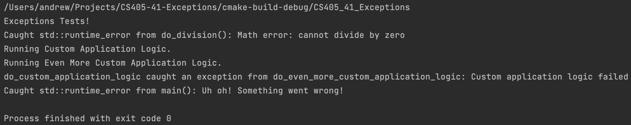

Implementing exception throwing and handling was a fairly simple task. The hardest part was figuring out where to begin, but I was able to work my way through the code starting in main() and following the chain of method calls. I did not run into any issues after that, and I did not run into any compile errors.